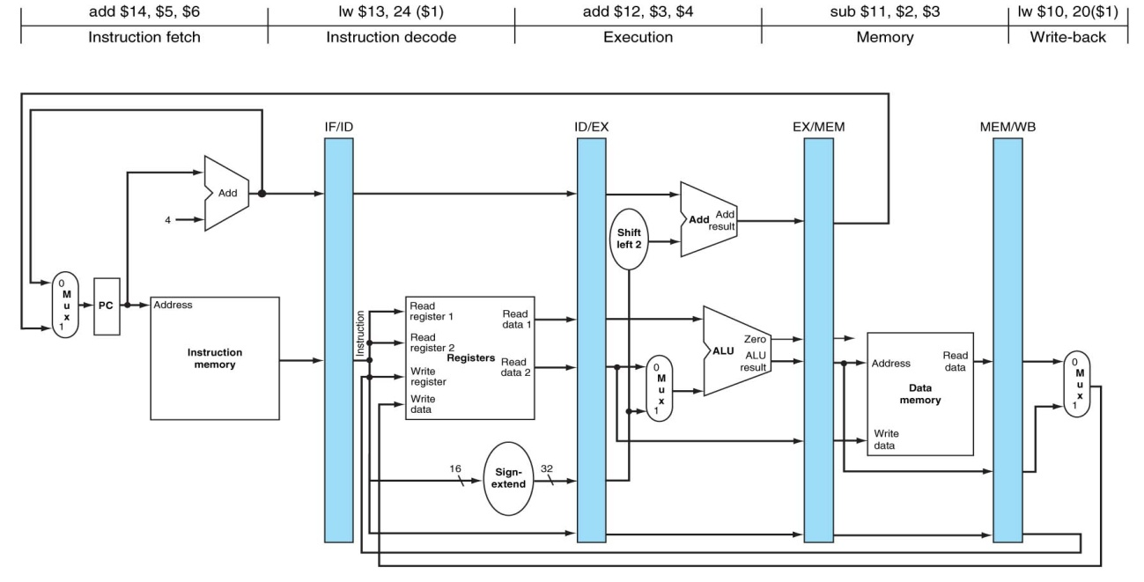

ENUNCIADO **PROBLEMA 3**:

**$7** = 4

**$1** = 16

**$2** = 10

**$6** = 1000

**MEM[44]** = 200

**Método utilizado para resolver los riesgos de datos**: bloqueo, anticipación.

|  |  |  |  |  |  |  |  |  |  |
| --- | --- | --- | --- | --- | --- | --- | --- | --- | --- |
|  | **Ciclo 1** | **Ciclo 2** | **Ciclo 3** | **Ciclo 4** | **Ciclo 5** | **Ciclo 6** | **Ciclo 7** | **Ciclo 8** | **Ciclo 9** |
|  |  |  |  |  |  |  |  |  |  |
|  |  |  |  |  |  |  |  |  |  |
|  |  |  |  |  |  |  |  |  |  |
|  |  |  |  |  |  |  |  |  |  |
| **LW $1, 40($7)** |  |  |  |  |  |  |  |  |  |
| **SW $6, 8($1)** |  |  |  |  |  |  |  |  |  |
| **ADD $9, $2, $2** |  |  |  |  |  |  |  |  |  |
| **Comentarios** |  |  |  |  |  |  |  |  |  |